From: http://www.unz.com/ishamir/unz-goes-nuclear/
Unz Goes Nuclear
ISRAEL SHAMIR • DECEMBER 6, 2018
• 2,500 WORDS • 423 COMMENTS • REPLY

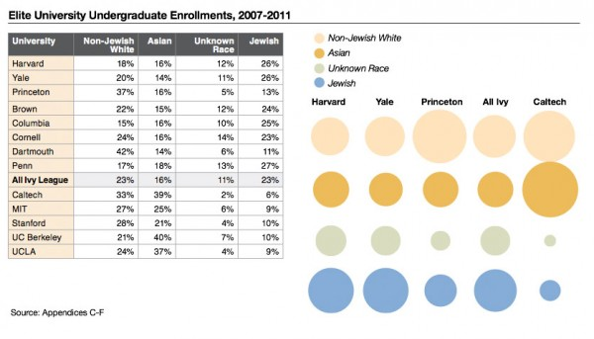
Some discoveries are just too shocking to digest. Recently I wrote of intrepid Ron Unz, the Californian maverick publisher and IT-genius, who dared to share with his readers his insights into the ideas and motifs of revisionists, or Holocaust Deniers, as their enemies call them. But this absolutely verboten topic fades into irrelevance in comparison with his most momentous discovery that has made somewhat less resonance, paradoxically, because of its magnitude. It was too big. Dark pages of the world war history or of interracial relations in 1930s, or even the whodunit of 9/11, all that is fine and very interesting, but hardly a Stop Press kind.
His other, most significant discovery is not just Stop Press, but Burn the Press Down. He discovered and proved with hard data that Jews discriminate against you to a degree you could not even guess. While you queue at the front door of the Elites, they enter freely by the back door. Chances of a smart non-Jewish “white” American kid getting there are ten-fold lower than that of a Jew. There are ten times more smart non-Jewish white American kids than smart Jewish kids, but there are more Jewish students in the Ivy League than white non-Jews. The system is biased, and not in your favour.
Once you could work your way up to success, like Henry Ford did. That was the American Dream. Not anymore. Now the only way to the best jobs, into the American elites leads through a few top colleges of the Ivy League. You can’t bypass this funnel of opportunity. “A greater and greater proportion of our financial, media, business, and political elites being drawn from a relatively small number of our leading universities” (all unattributed quotes are from the Unz essay). Unless you get the imprimatur of Harvard or Yale, your future is dim. Well-paid middle class jobs in the manufacturing sector for those lacking college degrees are scarce, and workers are being paid less now than forty years ago. When America’s richest 1 per cent has as much wealth as the bottom 95 per cent, it is winner takes all, and this winner is probably a Jew.
The elites have duties, too. The elite universities are supposed to pick the best boys and girls to lead America to its glory and greatness. By your own experience you already know that it does not happen; that the new US elites lead themselves to prosperity, while pushing you to poverty and perdition. The new elites failed you, failed your country, failed the world (always excepting the Jewish state). This failure is the main reason to explore how the elites produce their new generation.
The great surprise is that WASPs, the legendary descendants of the Founding Fathers, have lost their privilege, or even their fair chance to success. Unz proves that a smart Christian American boy of English or German parentage has ten times less chance to get into these crème-de-la-crème universities than an average Jewish boy. This very unfair way of forming tomorrow’s elites has been made possible by the sheer nepotistic networking of the universities’ admission offices. Clannishness, the Jews were (justifiably) accused of.
In actual words of Ron Unz, “Jews are enrolled at Harvard and other elite colleges at a rate some 1,000% greater than white Gentiles of similar academic performance”. One thousand per cent, OMG! Provided that these Ivy League colleges are the only sure-fire way into American elites, into best jobs and into good and important positions, this biased enrolment guarantees the Jews their position of the top dog well into next generation.
In 1920s, Jews accused the WASPs of discriminating them at university admission. The WASPs kept them under 15% of admissions. Now with Jews at the top they show what real discrimination is all about. However, there is one major difference. Then, the Jews volubly complained, now the Christians do not even dare to complain.
While the White Christian Americans kept mum, the Asians dared to speak and went to court against the colleges. The colleges have been forced to explain how they admit students. The heavily-Jewish elites of the legal system and MSM allowed this case of Asian-Americans to proceed (after many years of rejection) for a good reason: they wanted to obscure this fragrant discrimination against white Gentiles by Jews by a SEP device.
In Douglas Adams’s 1982 novel Life, the Universe and Everything, (a sequel to his Hitchhiker’s Guide), the protagonist explains: a SEP is something we can’t see, or don’t see, or our brain doesn’t let us see, because we think that it’s somebody else’s problem. That’s what SEP means. Somebody Else’s Problem. The brain just edits it out, it’s like a blind spot. SEP is the best way to hide a pink elephant in a room: people would have walked past the elephant, round it, even over it, and simply never have noticed that the thing was there.
The problem of Asian-American discrimination is an excellent SEP. Indeed, as Unz said, the Asian-Americans are discriminated at Ivy League universities (though much less than ordinary Americans). But even if they are discriminated, who cares? There are not too many of them, and they anyway manage well. Thus the real point of Unz – you are discriminated! – had been hidden.
The UNZ essay is very long with its 26,000 words, too long for average reader, so here are its salient points:
- Jews organized a clannish network to get themselves into best universities in numbers well beyond their share in population, and (!!!) well beyond their abilities;
- their fight against discrimination of Blacks has being carried at the expense of America’s white Christians. If previously discriminated minorities, be it Afro-Americans or whatever, enjoy the fruits of affirmative action (positive discrimination), it is no loss for Jews, as only Gentiles, once privileged WASPs are being screwed up.
- if once upon a time Jews had got into best colleges because they were smart, smarter than Gentile kids, now they are noticeably less smart, but they get there anyway because they are Jews.
The numbers distilled by Ron Unz out of dusty spread sheets are terrifying. You can look at the diagram he compiled, or immerse yourself in the ocean of data he provides, to get convinced: the discrimination is very real.
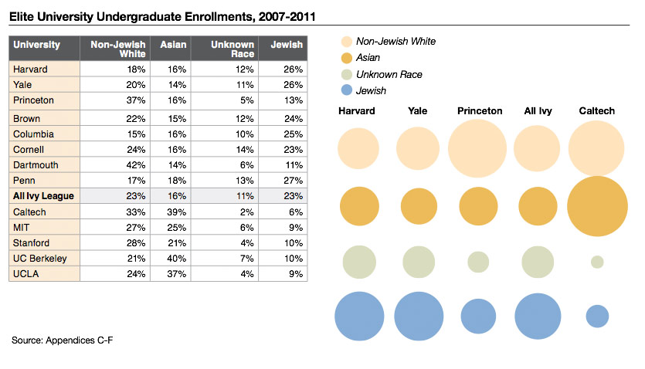
Unz quotes a Jewish writer who exhilarates that “the WASP demographic group which had once so completely dominated America’s elite universities and virtually all the major institutions of American life had by 2000 become a small and beleaguered minority at Harvard, being actually fewer in number than the Jews whose presence they had once sought to restrict.” For a Jewish nationalist, it is a cause for celebration. For a WASP, it is a reason to regret the unwise decisions of his fathers who tried to play a fair game with Jews and were Jew’d.
But for an average American, the answer lays in the macro picture. Do the new Jewified elites manage America better than WASPs did? Are they better shepherds? Is America-2018 (with Jews getting over 25% of all seats in the express train to better future, leaving 20% or less to WASPs) better for Americans than America-1962 with 15% of Jews and 80% of WASPs in Yale and Harvard? If you belong to 1% of Americans, the answer is positive; if you are one of the 99%, it is not.
Unz is very meticulous, very cautious in his approach. He asks an almost-insulting question: perhaps the Jews are so smart (after all, that is the kin of Einstein and Freud) that their share in the Ivy League is a result of meritocratic selection? And he provides an almost-insulting answer: no, they aren’t. There are some universities that admit strictly by merit; in these universities Jews do not exactly star. Caltech, the California Institute of Technology is one of them. The Jewish presence there is quite small; Hillel, the Jewish students’ body, gives it as zero. In reality, it is about 6 per cent, like in other merit-based competitions.
It can’t be zero, for sure. In 2003, two Palestine Solidarity activists, Adam Shapiro and Huwaida Arraf, had been booed there by pro-Israeli Jews who tried their beastly best to drive away the speakers. But there are not many Jews. There are few Jewish Olympiad winners; once they were in dozens, now there are hardly any. Altogether Jewish kids make up some six per cent of NMS, the highest-performing students’ list. This is a good result, in line with Jewish admissions into meritocratic colleges, but it is four times less than what you would expect judging by their Yale admissions. The Jewish IQ, as Unz found out, is also in line with that of their Gentile peers, and not the fabulous 110-115, as the Jewish newspapers claim. Jews are not all that smart anymore, judging by their score.
Unz explains this “sudden collapse of Jewish academic achievement” by inertia. The youngsters just do not try hard enough, in contradistinction to their fathers’ generation. They will succeed, they think, by their old-school-tie connections or through their parents’ links. Indeed when you look at the face of President Trump’s son-in-law, Mr Jared Kushner, you understand that the Nature took a nap in his generation. His parents’ generation were predators and major crooks (his father actually served two years in jail for tax evasion while obtaining his two-billion-dollar loot), but Jared’s generation could not enroll or graduate without assistance, while his political meddling made a mess of already troubled American Middle East politics.
This is the Nature way to deal with problems. Thomas Mann in his 1901 novel Buddenbrooks subtitled The Decline of a Family depicts three generations of a North German family: the first generation amasses fortune, the second maintains it, the third wastes it away in Bohemian pleasures. Smart people’s kids are usually not that smart, and have much less drive. For this reason, I wouldn’t be bothered too much by Jewish achievement of the elder generation; the young generation will waste it all right.
The problem is, there is more than one way to shine. One is to be brilliant, another is to dim others to shine in their background. In Israel, the Jews promoted plethora of laws and regulations circumscribing Palestinians’ ability to compete. In the US, Jewish support of migration from underdeveloped countries and discrimination of the white American students achieve a similar effect as it lowers the average ability of non-Jewish population and allows the Jews to excel in comparison.
Unz exploration could bring enormous benefits to the American society. His diagnosis of the malady allows to cure it. In his consequent article on the subject, Unz discovered that after publication of his article, the numbers of Jewish admissions in the best colleges had been sharply readjusted downwards. What was 25% (Jews in Harvard) became 12%. But do not rejoice before time. The Jews responded with subterfuge instead of correcting action. Now they refer in their statistics only to Jews who state that they are followers of Jewish faith; and this is a dwindling lot. If one counts the students who refer to themselves as “descendants of Holocaust survivors” and speak of “my true home Israel”, we are back to 25%.
So the US Jews have learned how to perpetuate their dominance, by jealously guarding the gates of the best universities. Can it be corrected?
Jews broke the glass ceiling of admissions to Harvard by mass protests and media pressure. The Gentiles are not likely to emulate their strategy as they became even more obedient and placid as if being bred for these traits. The Americans aren’t rebellious by nature; that’s why the US is so prosperous and that’s why the lot of a working American is going from bad to worse. Yes, Scylla and Charybdis guard the passage to well-being: over-rebellious folk grows poor as revolutions diminish the treasury; on the other hand, over-docile folk grows poor because their betters oppress them fearing not for harsh response. Wise elites navigate these narrow straits cautiously like the Swedes did until 1990. Obstinate elites have to be cured by revolution, like in England or France, or by state terror, as in Russia or China.
Now you have to live with Jewified elites. Historically, the record is not encouraging. Jews are not very good in the top dog position. They are too obstinate, doctrinaire and despise the low classes to whom they feel no affinity. A single person of Jewish origin can be very good as a leader (Bruno Kreisky, the Austrian chancellor, is a good example). Some Jewish politicians are very loyal – the much-denigrated Kaganovich remained loyal to Stalin when all the rest switched to Khrushchev. But when Jews form a prominent part of elites, like it happened in a few states in different times, the result is not very good. We have the example of Israel, where the natives have neither basic rights nor citizenship, and by millions they are deprived of property and locked up in the ghetto of Gaza.
The Unz revelation demonstrates the main feature of Jews: as a rule, they are immoral (or, if you prefer, they have a different, Jewish moral, as many Rabbis claim). It gives them an advantage in some dealings but eventually courts disaster. In the Tsar’s days, the Jews complained vociferously about two things: one, Numerus Clausus, (a Jewish quota of students) and two, the Pale of Settlement, a part of the country where Jews could reside freely. They – my grandparents – sounded so sincere denouncing these evils. Nowadays, the victorious Jews established the Pale of Settlement for Gentiles in Palestine, while in the US, they fixed the low quota for previous lords of the land, and very few Jews complain about it, as I noted at length.
When it is good for Jews, it is bad for Gentiles, says the Talmud. “If you hear that Caesarea (a symbol of Gentile rule) and Jerusalem (a symbol of Jewish rule) are both in ruins or that both are flourishing peacefully, do not believe it. Believe only a report that Caesarea is in ruins and Jerusalem is flourishing or that Jerusalem is in ruins and Caesarea is flourishing”. (Talmud, Tractate Megillah 6a). History confirms it – up to a point. Jews can have it good under Gentile rule, though not as good as they would like to. But under Jewish rule, not only Gentiles, but even middle-to-low-class Jews are being screwed up, as you can observe in the Jewish state of Israel – and in the heavily Jewified US, as well. Like fire, like women, – Jews are good when under control and dangerous and destructive when they are in control.
Still, there is a free will; everyone can choose one’s own way. Nobody born in the Jewish family has to stick with Jews. The best of Jews, from Christ Apostles to Joseph Brodsky and Ron Unz always escaped it to join the people.
[Author] Israel Shamir can be reached at adam@israelshamir.net
This article was first published at The Unz Review.
← Phanar Phantom

